

|  |
| --- |
| Version 1.0  **Last saved by:** Ben McGregor  **Last saved on:** 01/04/2015 |
|  |

|  |
| --- |
| Test Plan |
| 16/09/2014 |
| **Stephen Tate**  CO600: JustHealth Supervisor: Yang He |

Contents

1. Introduction 2

1.1. Objectives 2

1.2. Testing Strategy 2

1.3. Scope 2

2. Roles and Responsibilities 3

3. Test Results 3

3.1. Pass Criteria 3

3.2. Failing a Test 3

3.3. Test Case Errors 3

4. Testing Process 4

4.1. Schedule 4

4.2. Documenting Testing 4

4.2.1. Test Cases 4

4.2.2. Test Case Cover Page 5

4.2.3. Administration Procedures 5

4.3. Assumptions 6

4.4. Test Deliverables 7

5. Test Cases 8

5.1. Iteration 1 8

Appendix One: Failed Tests 9

# Introduction

This test plan is designed to outline the scope, approach, responsibility and schedule for all testing components. It will explicitly identify what is to be tested, the types of testing to be utilised, who is responsible for carrying out the testing and defining the testing schedule. Also, this plan will detail any assumptions and risks that may be associated with the plan.

## Objectives

This test plan should outline a set of complete tests that are associated with every feature and functionality that JustHealth provide, in both their mobile and web applications. The test plan will detail in its entirety which tests apply specifically to the mobile and web application.

Before any feature is able to be added to a product version that is to be released, the feature must have passed all testing associated with it. This must have been signed off by the Tester and verified by the Test Manager.

The test plan will be a key document milestone for every feature; if it does not pass the required tests any version of software that contains the feature will not be released.

## Testing Strategy

JustHealth have adopted a test-driven development strategy, all of the test cases will be written and based on the requirements that the web application and mobile application are expected to fulfil. Furthermore, due to the test-driven development that it being adopted throughout the project and each iteration the predominant testing utilised will be unit testing which will be mainly black box testing although, for some tests white box testing may be more appropriate.

## Scope

This test plan covers JustHealth for all of the testing that they carry out throughout the development lifecycle of both the JustHealth Web Application and the JustHealth Mobile Application. The JustHealth web and mobile applications are dependent on the testing and therefore, this will be something that will be continually performed throughout the development lifecycle of the products.

# Roles and Responsibilities

|  |  |  |
| --- | --- | --- |
| Role | Name | Responsibility |
| Tester | TBD | The tester is responsible for carrying out the tests that are detailed in the test cases. The tester is responsible for adding any problems that they come across to the issue tracker and also responsible to assign any issues that they open and inform that person of the issue. The tester is responsible for ensuring that any test that fails is performed again.  *Note: The tester should not be the same person that has written the code for the specified functionality. Exceptions may be granted if no other tester is available.* |
| Test Manager | Stephen Tate | The test manager is responsible for verifying all test cases are complete and test the desired functionality completely. Also, they are responsible to ensure that all tests are performed correctly and accurately. The test manager must verify and sign all test cases before any functionality is able to be added into a version of software that is suitable for release.  *Note: In the event that the Test Manager carries out the testing, both the technical and project managers will be required to sign the test cases too.* |

# Test Results

## Pass Criteria

In order for a test to be marked as a pass, the expected test result which is written in the test case should be identical to the actual result. If this is not the case the test should be failed.

## Failing a Test

Any fail that is recorded should subsequently be added to the issue log and assigned to the most appropriate person to track and follow through with the issue. If the test is unable to be passed even after troubleshooting, yet needs to be added to the software that is available for release, then a risk will need to be raised. This will need to be acknowledged using the document template that can be found in appendix one and signed by the Risk Manager, Test Manager, Technical Manager and the Project Manager.

## Test Case Errors

If any errors are found within the test cases then an issue should be raised in the issue tracker. This should be followed up and amended by the tester and will be approved by the Test Manager once the test cases have been completed.

# Testing Process

## Schedule

Test cases will be designed at the start of each iteration and should be completed and agreed by the Test Manager before any coding commences.

The testing itself should be performed at the end of each iteration before the desired functionality is able to be added into the version that is identified as being fit for release. As JustHealth work on two week iterations it would be expected that testing also takes place every fortnight.

## Documenting Testing

### Test Cases

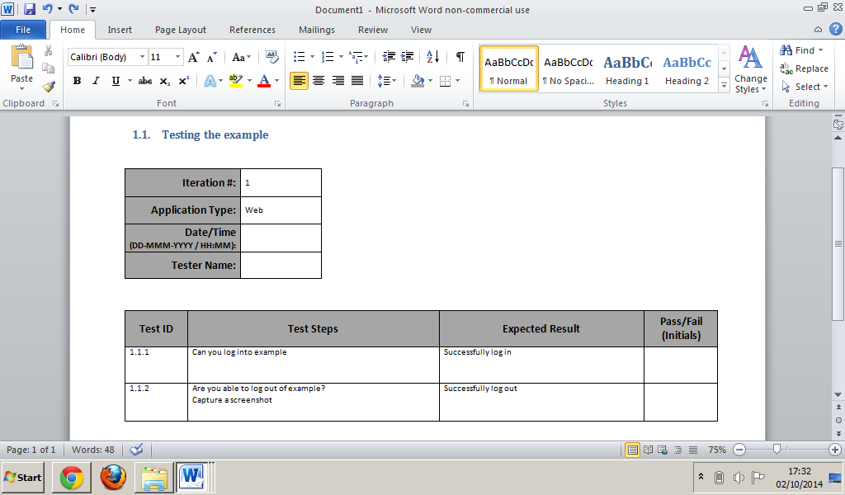The tester is required to fill in all of the fields that are highlighted in red. The tester should also be aware of the tests that require a screenshot; the text is highlighted in green below.

### Test Case Cover Page

The bottom table should be filled in firstly by the tester(s) and lastly by the Test Manager.

### 

### Administration Procedures

The following procedures must be adhered to by all that are involved with any form of testing.

#### Handwritten

All test cases should be filled out by hand and filed by the Test Manager.

#### Mistakes

All mistakes should be crossed through with a single line and initialled by the person that made the mistake.

#### Failed Tests

All tests that fail should be re-tested and have a new test case printed and filled out. The failed test cases should be stored and must not be destroyed.

#### Screen Shots

Where indicated screen shots should be obtained and included within an additional document to the test plan. Associated with all of the iterations that are carried out, there should be a separate document containing the screen shots; this will be created when the test cases are created. Tests that fail should have captured screenshots in the documents and should be mark appropriately.

## Assumptions

This test plan assumes that both the Tester and Test Manager have a full understanding of the tests that need to be carried out and are capable of carrying them out accurately. It also assumes that individuals are trustworthy and will carry out the tests unbiased; ensuring that documentation reflects the tests actual results.

## Test Deliverables

|  |  |  |  |
| --- | --- | --- | --- |
| Deliverable Name | Required? | Responsibilities | Signed By |
| Test Plan | Yes | **Test Manager:** The Test Manager should update the test plan with the test ID’s and names of each test associated with a particular iteration. Furthermore, the test manager is also required to initial individual tests in the test plan once he is satisfied that the test cases have been completed and filed.  **Tester:** The tester is required to date/time stamp and initial each individual test, once it has passed. | This document will need to be signed once all testing is complete by the Test Manager.  Each individual test will need to be initialled by the Tester and the Test Manager.  *Note: In the event that the Test Manager carries out the testing, both the technical and project managers will be required to initial the individual tests.* |
| Test Cases | Yes | **Test Manager:** The Test Manager is required to sign every test case once all tests in the test case have been passed or have the appropriate risks raised.  **Tester:** The test cases must be filled out by the tester accurately using the standard that has been outlined in this document. | All tests will need to be initial by the tester.  All test cases, once complete should be signed by the tester and Test Manager. |
| Screenshots Document | If tests require screenshots to be captured. | **Tester:** The tester is required to capture screenshots and paste them into the screenshot document for that particular iteration that the tests apply too. | N/A |
| Issue Entry | If any tests fail or issues are found with the test cases themselves. | **Tester:** The tester is responsible for raising the issues that are identified in the issue tracker and assigning these to the appropriate person. | N/A |

# Test Cases

## Iteration 1

|  |  |  |  |  |
| --- | --- | --- | --- | --- |
| Test ID | Test Name | Date/Time Completed | Tester Initials | Test Manager Initials |
|  |  |  |  |  |

# Appendix One: Failed Tests

